JANTA VIDYA MANDIR GANPATRAI RASIWASIA COLLEGE, CHARKHI DADRI
Faculty Profile

Department

Name of Faculty |  | Dr Rajinder Singh |  |  | 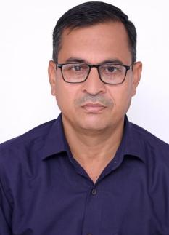
Department |  | Hindi
Designation |  | Assistant professor
Experience |  | 11 years
Contact No |  | 9896767667
Email Id |  | singhrajinder1629@gmail.com
Date of Joining |  | 02/08/13
Educational Qualification. M.A., M.Phil,Ph.D
 | Name of Program |  | Year of  Passing | University
PG | PG |  | 1997 | M.D.U.Rohtak
Ph.D. | Ph.D |  | 2003 | M.D.U.Rohtak
Net | - |  | - | -
Other | - |  | - | -
Research Supervision/Guidance |  | One
Research Publications |  | 30
Books Published |  | 04
Book Chapters |  | 05
Papers Presented in Conferences/ Seminar |  | International: 30 National: 20
Participated in Conferences/ Seminar |  | International: Nil National: Nil
No. of Workshops/FDP/Training Programme Attended |  | 06
Major/Minor Research Projects |  | Nil
Invited Lectures |  | 02
Awards/Honours |  | 04
Membership of Any  Professional/ Statutory Body |  | Nil
Any Other Achievement |  | Nil

